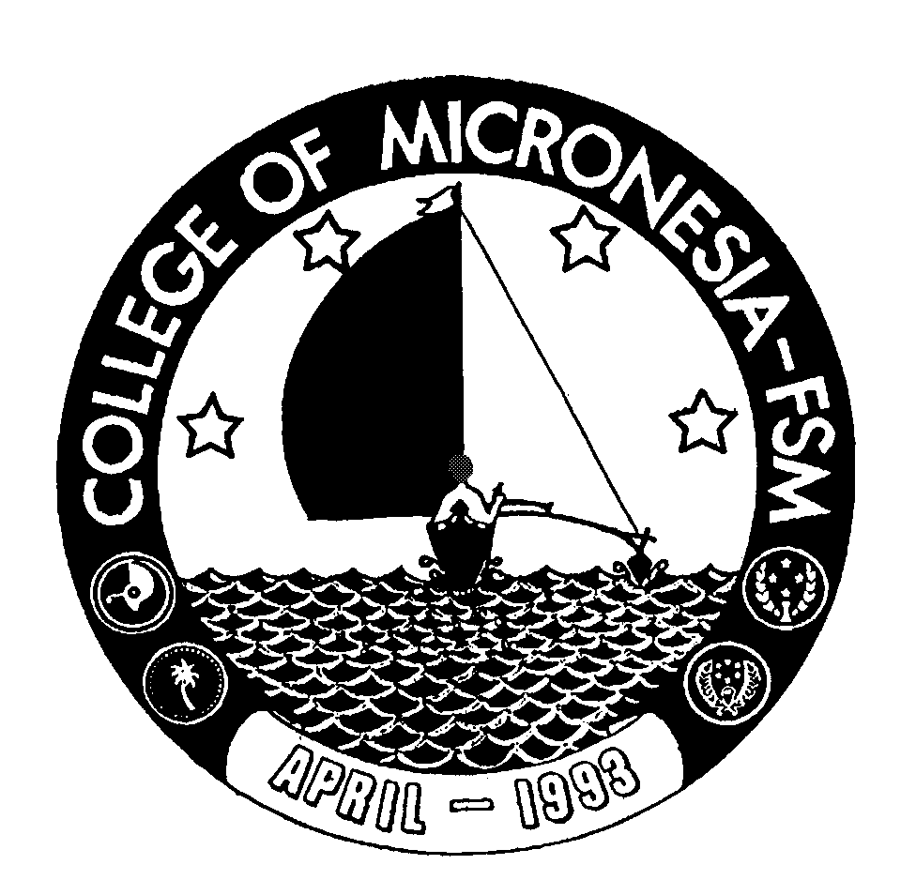 | College of Micronesia-FSM
P.O. Box 159
Kolonia, Pohnpei FM 96941
Phone: (691)320-2482/ 320-2481 |  | Fax: (691) 320-2479

REQUEST FOR OVERTIME WORK

Name of Requestor: Date:

Date |  | Project or Task  Requiring Overtime | Justification |  | Number of Hours Requested
 | Supervisor’s Signature |  |  | President’s Signature

