STRATEGIC PLAN
2006 – 2011

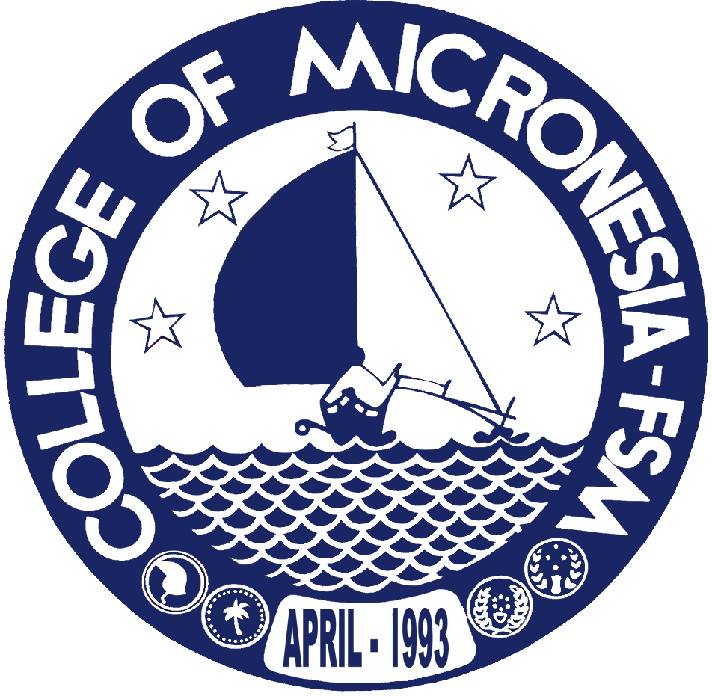

College of Micronesia –
Federated States of Micronesia

College of Micronesia – FSM

Board of Regents
Podis Pedrus, Chairman – Pohnpei State Representative
Joseph Habuchmai, Vice Chairman – Yap State Representative
Henry Robert, Secretary-Treasurer, Kosrae State Representative
Andrew Yatilman, Member-at-large
Vacant – Chuuk State Representative

President
Spensin James

College of Micronesia – FSM
P.O. Box 159
Kolonia, Pohnpei FM 96941
Phone: (691) 320-2480
Fax: (691) 320-2479

Prepared: August 2006
Updated:

For Information regarding the COM-FSM Strategic Plan, contact:

College of Micronesia – FSM
Office of Institutional Research and Planning
P.O. Box 159
Kolonia, Pohnpei FM 96941
Phone: (691) 320-2480
Fax: (691) 320-2479
Web site & directory: www.comfsm.fm
Email: jhicks@comfsm.fm

