College of Micronesia-FSM
P. O. Box 156
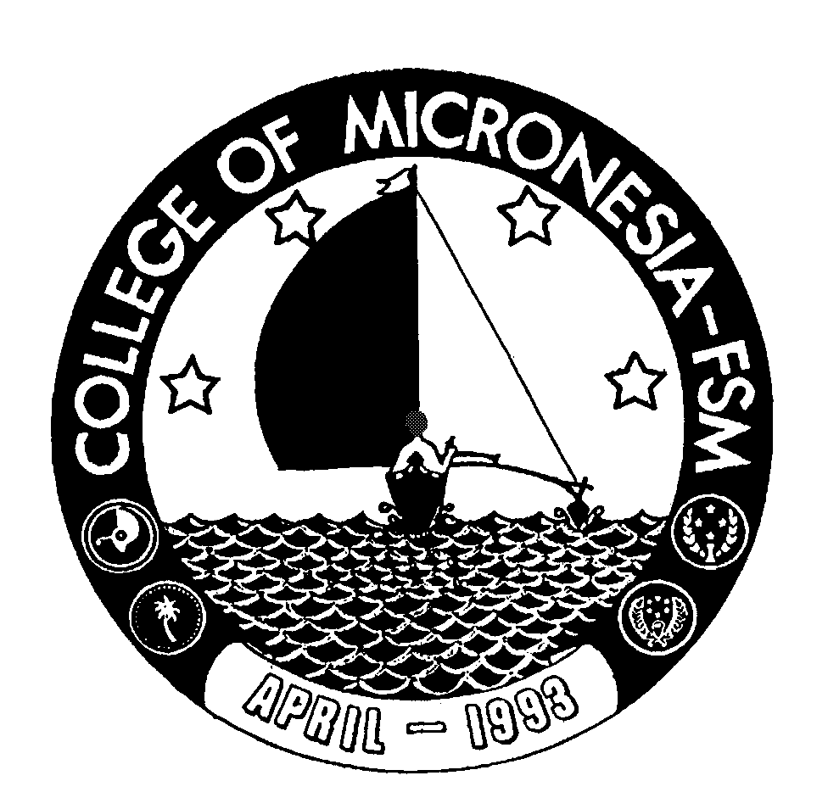
Kolonia, Pohnpei FSM 96941

Third-Year Certificate of Achievement
in
ACCOUNTING OR GENERAL BUSINESS

Name |  | State/Republic

GENERAL EDUCATION CORE REQUIREMENTS |  |  |  |  | MAJOR REQUIREMENTS
Choose one course from each area, or two from one area and | 9 credits |  | ACCOUNTING MAJOR
one from another. |  |  | (21 credits)
 |  |  | AC 320 Intermediate Accounting I |  |  |  | 3_____
Quantitative & Logical |  |  | AC 321 Intermediate Accounting II |  |  |  | 3_____
EN 208 Intro to Philosophy | 3_____ |  | AC 325 Cost Accounting |  |  |  | 3_____
MS 101 Algebra and Trig. | 3_____ |  | AC 330 Taxation |  |  |  | 3_____
 |  |  | AC 335 Government Accounting |  |  |  | 3_____
World Culture & History |  |  | AC 370 Accounting Internship |  |  |  | 3_____
SS 111 Cultural Anthropology | 3_____ |  | BU/MS 310 Applied Statistics |  |  |  | 3_____
SS 125 Geography of the Pacific | 3_____
SS 170 World History I | 3_____ |  | GENERAL BUSINESS MAJOR
SS 171 World History II | 3_____ |  | (21 credits)
SS 195 Micronesian Cultural Study |  |  | BU/MS 310 Applied Statistics |  |  |  | 3_____
 |  |  | MGT 320 Organization Behavior |  |  |  | 3_____
Humantities |  |  | MGT 350 International Business |  |  |  | 3_____
AR 101 Intro to Art | 3_____ |  | MGT 360 Entrepreneurship & Small Bus. |  |  |  | 3_____
MU 101 Intro to Music | 3_____ |  | MKT 311 Marketing Strategy |  |  |  |  | 3_____
EN 201 Intro to Literature | 3_____ |  | ECO 320 Economic Development |  |  |  |  | 3_____
FL 101 Intro to Japanese | 3_____ |  | FIN 312 Corporate Finance |  |  |  |  | 3_____
 |  |  | Total Graduation Requirements |  |  | 30 Credits

