College of Micronesia-FSM
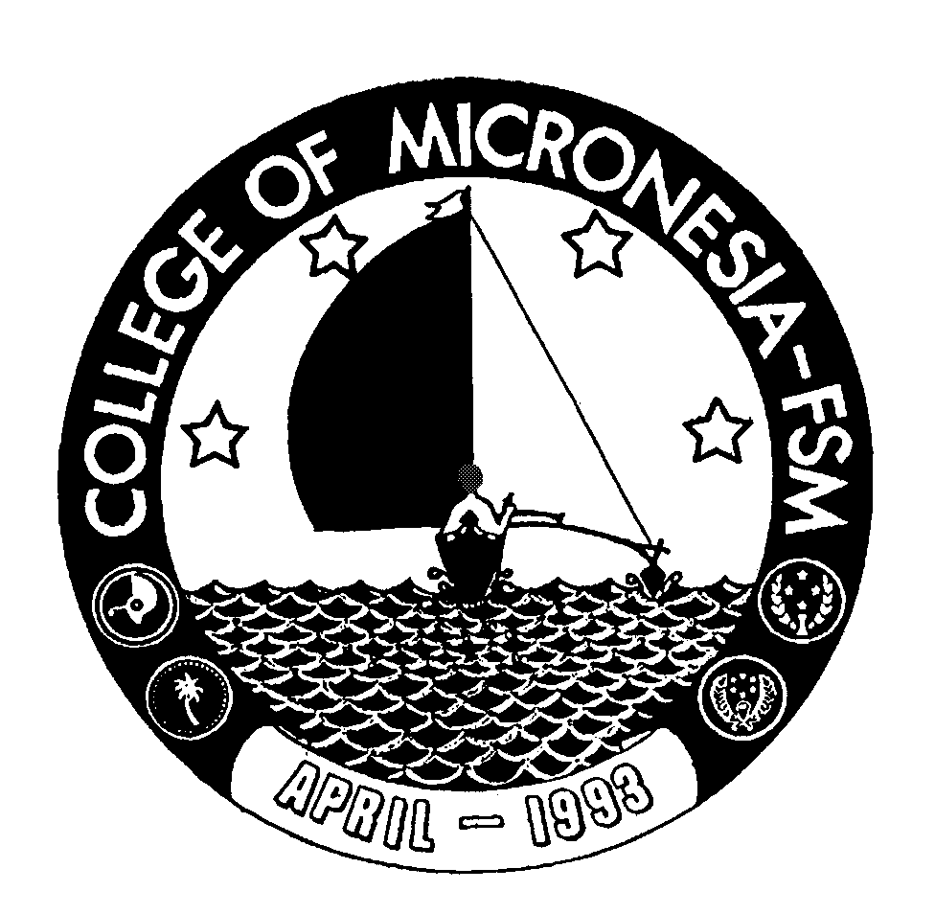

P. O. Box 159

Kolonia, Pohnpei FM 96941

CERTIFICATE OF ACHIEVEMENT

In

Trial Counselors

Name: ______________________________________ State: _____________________

Date of First Test |  |  |  |  | Placement Test
 | English  Listening/Speaking |  |  | English Structure |  | English Reading | English Total | Math

Major Requirements (30 credits) Credits Grade Sem

LAW 200 Legal Research and Writing | 3 | ______ | ______
LAW 210 Criminal Procedure | 3 | ______ | ______
LAW 215 Criminal Law | 3 | ______ | ______
LAW 220 Torts | 3 | ______ | ______
LAW 224 Contracts | 3 | ______ | ______
LAW 228 Evidence | 3 | ______ | ______
LAW 232 Constitutional Law | 3 | ______ | ______
LAW 236 Appellate and Civil Procedure/Jurisdiction | 4 | ______ | ______
LAW 238 Real Property | 2 | ______ | ______
LAW 240 Trial Practice Internship | 3 | ______ | ______

Total Certificate Requirements 30 credits

