College of Micronesia-FSM
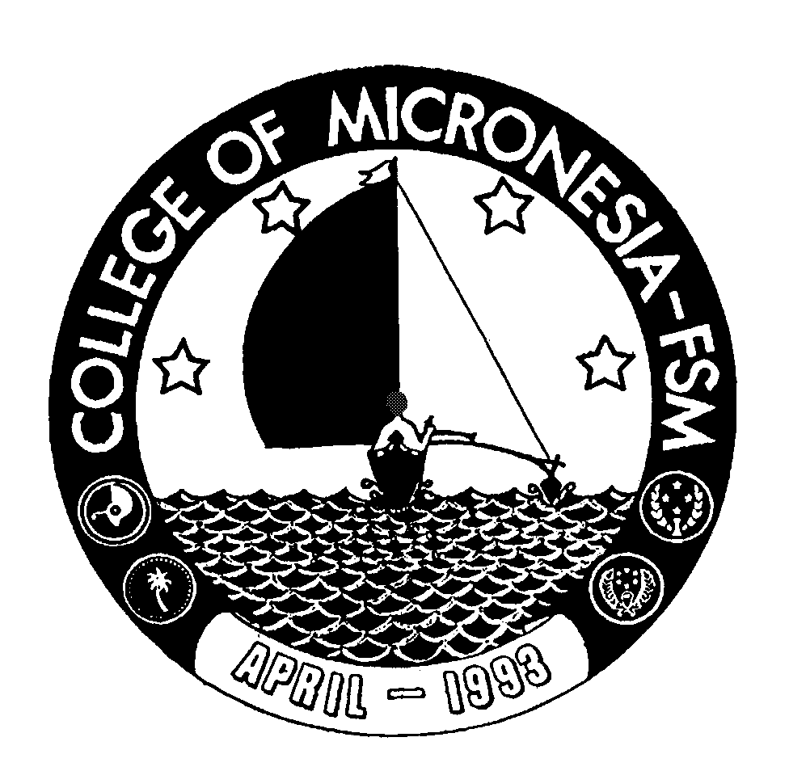

P. O. Box 159

Kolonia, Pohnpei FM 96941

CERTIFICATE OF ACHIEVEMENT

In

Secretarial Science

Name: ______________________________________ State: ___________________

Date of First Test |  |  |  |  | Placement Test
 | English  Listening/Speaking |  |  | English Structure |  | English Reading | English Total | Math

Major Requirements (34 credits) Credits Grade Sem

BK 095 Bookkeeping | 3 | _____ | _____
BK 096 Bookkeeping | 3 | _____ | _____
BU 095 Filing, Office Procedure/Office Machines | 3 | _____ | _____
BU 098 Basic Business Math | 3 | _____ | _____
BU 099b Office Management (200 hours practicum) | 3 | _____ | _____
CA 100s Computer Literacy for Secretaries | 4 | _____ | _____
CA 101s Computer Application for Secretaries | 4 | _____ | _____
ESL/BU 095 ESL for Business Purposes I | 4 | _____ | _____
ESL/BU 096 ESL for Business Purposes II | 4 | _____ | _____
SS 100 World of Work | 3 | _____ | _____

Total Certificate Requirements 34 credits

