College of Micronesia-FSM

P. O. Box 159
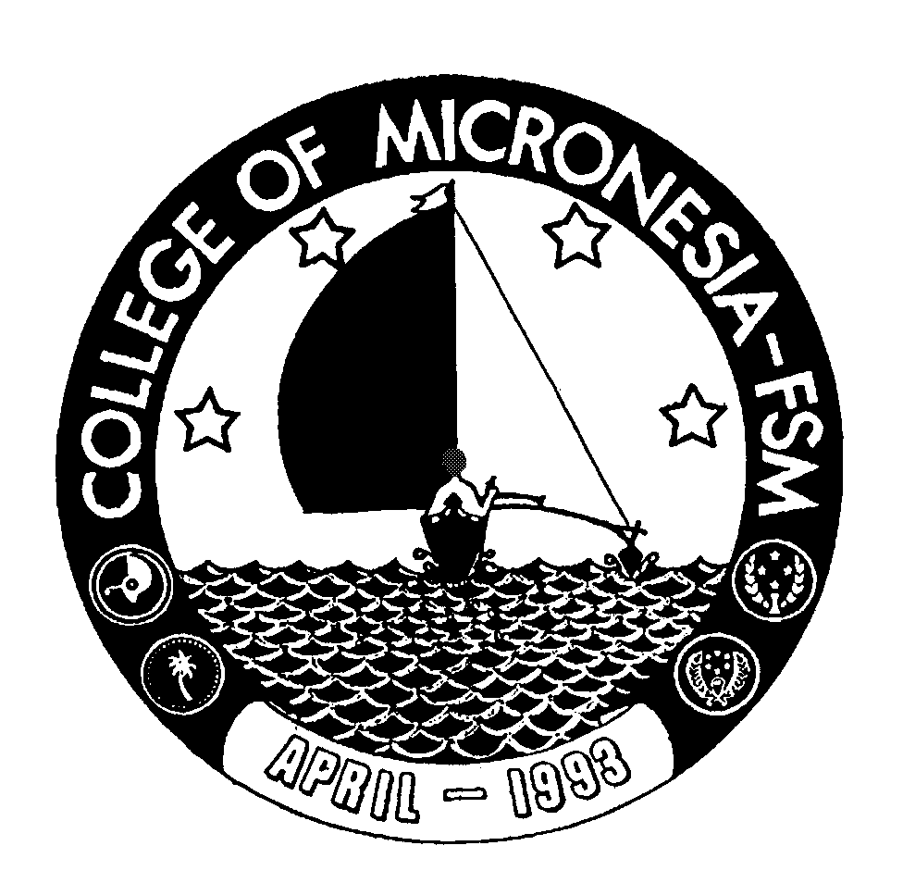

Kolonia, Pohnpei FM 96941

CERTIFICATE OF ACHIEVEMENT

In

Preschool Teacher Education

Name: _________________________________ State: __________________________

Date of First Test |  |  |  | Placement Test
 | English  Listening/Speaking |  |  | English Structure | English Reading | English Total | Math

MAJOR REQUIREMENTS (32 credits) Credit Grade Sem

ED/CD 100 Introduction to Early Childhood Education | 4 | _____ | _____
ED/CD 101 CDA Orientation, Safety, and Healthy Learning Environment | 4 | _____ | _____
ED/CD 102 Promoting Physical and Communication Skills | 4 | _____ | _____
ED/CD 103 Advancing Cognitive Skills through Creative Experiences | 4 | _____ | _____
ED/CD 104 Promoting Self-Esteem and Responsible Behavior Through  Social Experiences | 4 | _____ | _____
ED/CD 105 Family Involvement in Preschool Education | 4 | _____ | _____
ED/CD 106 Program Management and Professionalism | 4 | _____ | _____
ED/CD 107 Practicum | 4 | _____ | _____

Total Certificate Requirements 32 credits

