College of Micronesia-FSM

P. O. Box 159
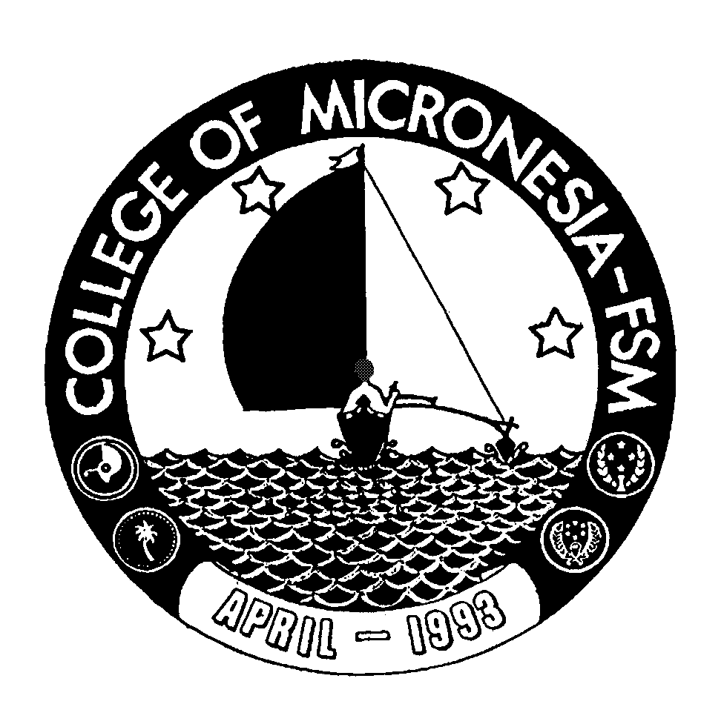

Kolonia, Pohnpei FM 96941

CERTIFICATE OF ACHIEVEMENT

In

Law Enforcement

Name: ______________________________________ State: _____________________

Date of First Test |  |  |  |  | Placement Test
 | English  Listening/Speaking |  |  | English Structure |  | English Reading | English Total | Math

General Education Core Requirements (16 credits) Credits Grade Sem

CA 100 Computer Literacy | 3 | _____ | _____
MS 095 Pre Algebra | 4 | _____ | _____
ESL 087 Listening/Speaking II | 3 | _____ | _____
ESL 089 Reading V | 3 | _____ | _____
ESL 099 Writing V | 3 | _____ | _____
Major Requirements (18 credits)  SS/PY 101 General Psychology | 3 | _____ | _____
AR 101 Introduction to Arts | 3 | _____ | _____
AJ 151 Introduction to Criminal Justice | 3 | _____ | _____
AJ 152 Introduction to Law Enforcement and Security | 3 | _____ | _____
AJ 155 Administration Laws of Arrest, Search and Seizure | 3 | ______ | _____
AJ 158 Management Skills for Police Officers | 3 | ______ | _____

Total Certificate Requirements 34 credits

