College of Micronesia-FSM
  - O. Box 159
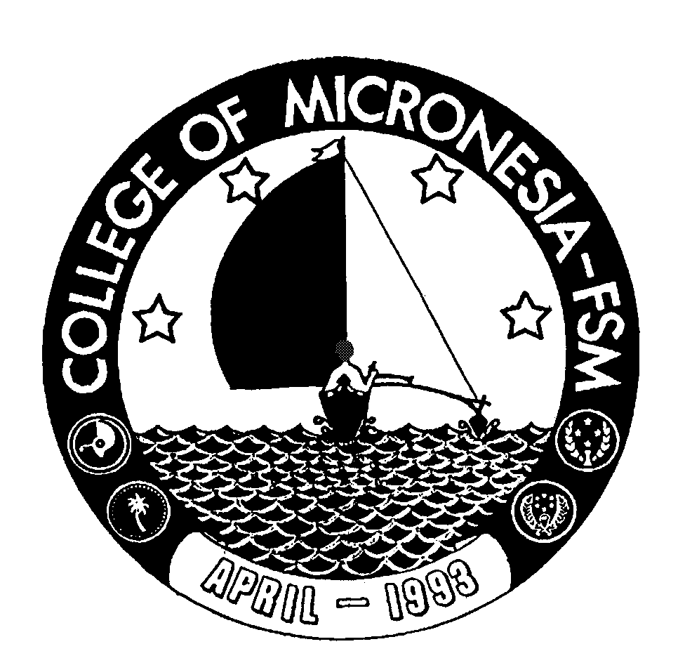
Kolonia, Pohnpei FSM 96941

CERTIFICATE OF ACHIEVEMENT
In
Health Assistant Training Program

Major Requirements (46 credits) Credits Grade Sem

CHS 220 Review of Health Sciences 5 ________ _______
CHS 224 Health Problems in Adult 5 ________ _______
CHS 231 Maternal and Child Health I 5 ________ _______
CHS 232 Non-Communicable/Communicable Disease 5 ________ _______
CHS 233 Behavioral Health 2 ________ _______
CHS 234 Human Nutrition 3 ________ _______
CHS 235 Dental Health 2 _______ _______
CHS 240 Maternal and Child Health II 5 ________ _______
CHS 241 First Aid Care 3 ________ _______
CHS 242 Environmental Health 2 ________ _______
CHS 244 Dispensary Management 5 ________ _______
CHS 251 Health Problems in Children 5 ________ _______

Total Certificate Requirements 47 credits

