COLLEGE OF MICRONESIA-FSM
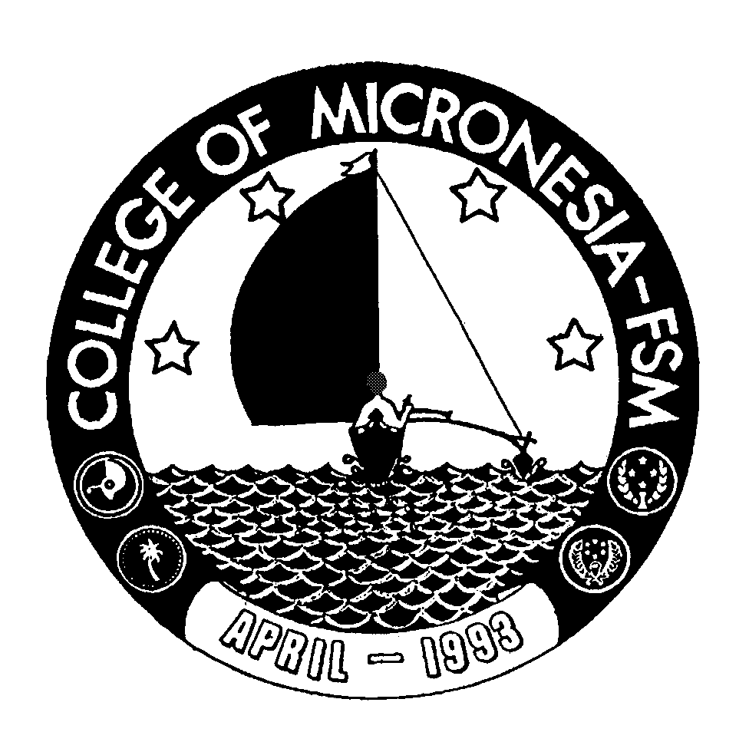

P. O. Box 159
Kolonia, Pohnpei FM 96941

CERTIFICATE OF ACHIEVEMENT

In

General Studies

Name: ____________________________________ State: _____________________

Date of First  Test |  | Placement Test
 | English  Listening/Speaking |  | English  Structure | English  Reading | English  Total | Math

Certificate Core Requirements (16 credits) Credits Grade Sem
English (12 credits)
ESL 079 Study Skills | 3 ______ ______
ESL 087 Listening/Speaking II | 3 ______ ______
ESL 089 Reading V | 3 ______ ______
ESL 099 Writing V | 3 ______ ______
Mathematics (4 credits)
MS 098 Transition to Algebra | 4 ______ ______

Certificate Program Requirements (18 credits)
CA 100 Computer Literacy | 3 ______ ______
SC 094 Family Health | 3 ______ ______
SC 098 Survey of Science | 3 ______ ______
SS 098 Introduction to Social Sciences | 3 ______ ______
SS 100 World of Work | 3 ______ ______
Elective (3 credits)
Take one from the following group:
______ Intro. to Agriculture | 3 ______ _______
______ Intro. to Tourism | 3 ______ _______
______ Intro. to Construction Trades | 3 ______ _______
______ Intro. to Fishery and Marine | 3 ______ _______
______ Citizenship | 3 ______ _______
______ History and Government of FSM | 3 ______ _______

Total Certificate Requirements 34 credits

