College of Micronesia-FSM
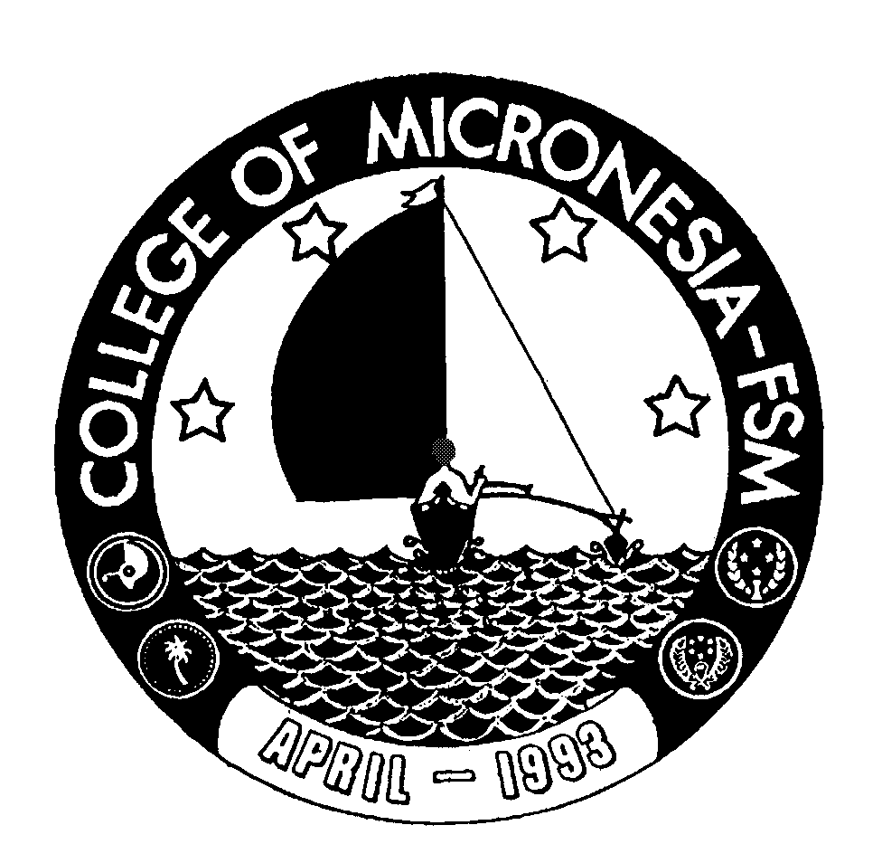

P. O. Box 159

Kolonia, Pohnpei FM 96941

CERTIFICATE OF ACHIEVEMENT

In

Agriculture and Food Technology

Name: ______________________________________ State: _____________________

Date of First Test |  |  |  |  | Placement Test
 | English  Listening/Speaking |  |  | English Structure |  | English Reading | English Total | Math

General Education Requirements (13 credits) Credits Grade Sem
CA 100 Basic Computer Applications 3 ________ ______
ESL 050 Technical English 3 ________ ______
MS 104 Technical Math I 4 ________ ______
SC 098 Survey of Science 3 ________ ______

Technical Requirements (21 or 22 credits)
AG 084 Basic Crop Production 4 ________ ______
AG 096 Field Internship 5 ________ ______
Plus a minimum of 12 credits from the following:
AG 086 Micro- propagation and Nursery Practices 4 ________ ______
AG 088 Landscaping 3 ________ ______
AG 090 Principles of Food Processing 3 ________ ______
AG 092 Swine and Poultry Production 3 ________ ______
AG 094 Farm Management and Marketing 3 ________ ______

Total Certificate Requirements 34-35 credits

