COLLEGE OF MICRONESIA-FSM
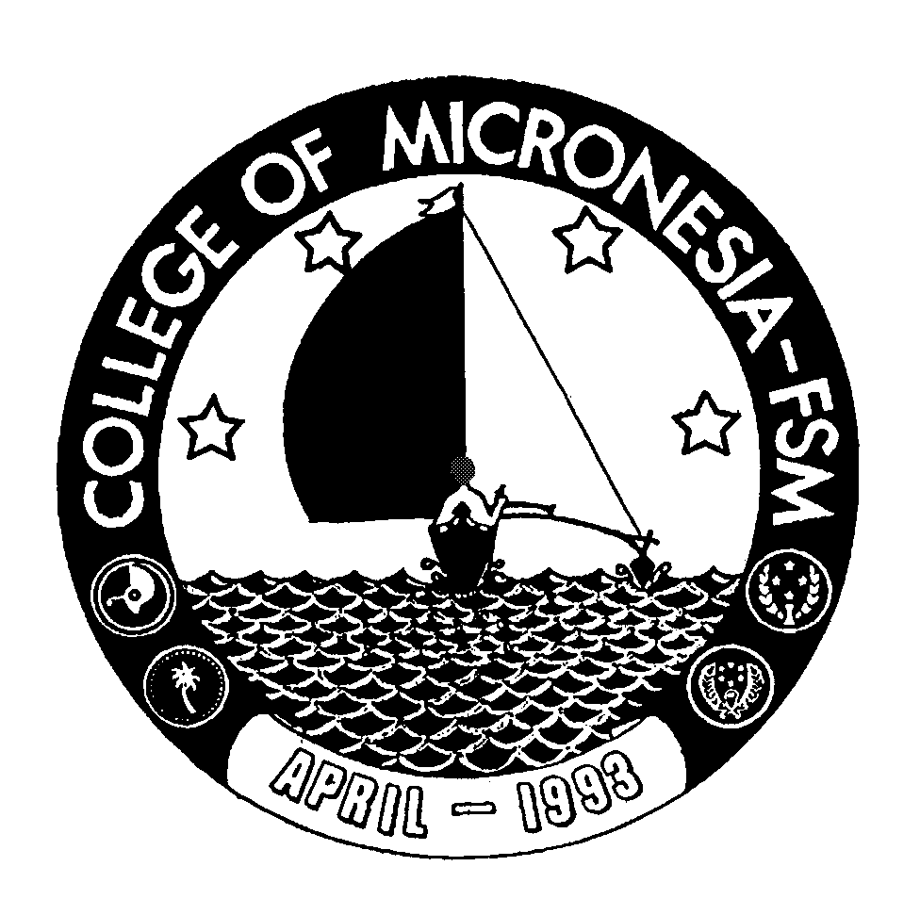
P. O. Box 159
Kolonia, Pohnpei FM 96941

Associate of Science Degree
in

MARINE SCIENCE

________________________________________ ___________________________
Name State/Republic

Date of First  Test |  | Placement Test
 | English  Listening/Speaking |  | English  Structure | English  Reading | English  Total | Math

GENERAL EDUCATION CORE REQUIREMENTS |  |  |  |  |  |  |  |  |  |  | MAJOR REQUIREMENTS
English (9 credits) |  |  |  |  |  |  |  |  | Marine Science (23 credits)
EN 110 Advanced Reading |  |  | 3_____ |  |  |  |  |  | MR 120 Marine Biology |  |  |  |  | 4____
EN 120a Expository Writing I |  |  | 3_____ |  |  |  |  |  | MR 201 Aquaculture w/lab |  |  |  |  | 4____
EN 120b Expository Writing II |  |  | 3_____ |  |  |  |  |  | MR 210 Marine Ecology |  |  |  |  | 3____
 |  |  |  |  |  |  |  |  | MR 230 Ichthyology w/lab |  |  |  |  | 4____
Mathematics (3 credits) |  |  |  |  |  |  |  |  | MR 240 Oceanography w/lab |  |  |  |  | 4____
Any 100 level or above |  |  |  |  |  |  |  |  | MR 250 Fishery Biology Management |  |  |  |  | 3____
Mathematics course |  |  | 3_____ |  |  |  |  |  | MR 254 Marine Biology Field Studies |  |  |  |  | 1____
 |  |  |  |  |  |  |  |  | Natural Science (4 credits)
Natural Sciences (7 credits) |  |  |  |  |  |  |  |  | SC 230 Introduction to Chemistry w/lab |  |  |  |  | 4____
Any two of the following courses, one of which must have a lab. SC 180, SC 201, SC 202, SC 220, SC 245, SC 250, SC 255, MR 252, SC 110, SC 111,  SC 210, SC/SS 115 |  |  | 3_____  4_____ |  |  |  |  |  | Mathematics (3 credits)  MS 150 Statistics |  |  |  |  | 3____
Social Sciences (3 credits) |  |  |  |  |  |  |  | Social Studies (3 credits)
SS 150 History of Micronesia |  |  | 3______ |  |  |  |  |  | SS 120 Introduction to Geography or |  |  |  |  | 3_____
 |  |  |  |  |  |  |  |  | One of the following: SS 101, SS 125,
Computer Application (3 credits) |  |  |  |  |  |  |  |  | SS 130
CA 100 Computer Literacy |  |  | 3______
Exercise Sports Science (1 credit)
ESS course | 1______ |  |  |  |  |  |  |  | Open Elective (3 credits)
Humanities (3 credits) |  |  |  |  |  |  |  |  | _________________________ |  |  |  |  | 3_____
Any course in Art, Music, History,
Philosophy, Language, or Culture may be taken |  | 3____
 |  |  |  |  |  |  |  |  | Total Graduation Requirements |  |  | 65 credits

