College of Micronesia-FSM
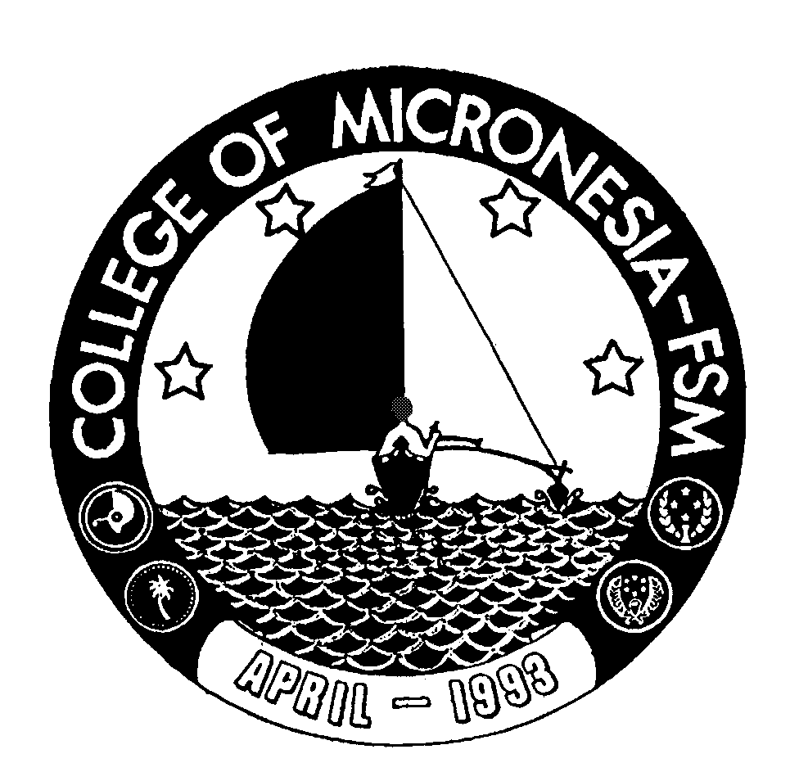
P. O. Box 159
Kolonia, Pohnpei FM 96941

Associate of Science Degree
in

Hospitality & Tourism Management

_____________________________________ _____________________________
Name State/Republic

Date of First Test |  | Placement Test
 | English  Listening/Speaking |  | English  Writing/Structure | English  Reading | English  Total | Math

GENERAL EDUCATION CORE REQUIREMENTS |  |  |  |  |  |  | MAJOR REQUIREMENTS
English (9 credits) |  |  |  |  | Hospitality and Tourism Management (24 credits)
EN 110 Advanced Reading |  | 3_____ |  |  | HTM 110 Introduction to HRM |  |  |  | 3____
EN 120a Expository Writing I |  | 3_____ |  |  | HTM 120 Introduction to World Tourism |  |  |  | 3____
EN 120b Expository Writing II |  | 3_____ |  |  | HTM 150 Hospitality Supervision |  |  |  | 3____
 |  |  |  |  | HTM 165 Food Fund & Quality Cooking |  |  |  | 3____
Mathematics (3 credits) |  |  |  |  | HTM 170 Front Office Management |  |  |  | 3____
Any 100 level or above Mathematics course |  | 3_____ |  |  | HTM 220 Food & Beverage Management |  |  |  | 3____
 |  |  |  |  | HTM 230 Tourism Marketing |  |  |  | 3____
Natural Sciences (7 credits) |  |  |  |  | HTM 250 Facilities Management & Pract. |  |  |  | 3____
A science with lab or AG 110 or 140 and |  | 4_____
A non lab Science or AG 101 |  | 3_____ |  |  | Accounting (3 credits)  AC 131 Accounting I 3_____
 |  |  |  |  | Business (3 credits)
Social Science (3 credits) |  |  |  |  | BU 101 Introduction to Business |  |  |  | 3____
SS 150 History of Micronesia |  | 3_____
 |  |  |  |  | Language (6 credits)
Computer Application (3 credits) |  |  |  |  | FL 120 Basic Japanese for Hotel &  Restaurant |  |  |  | 3____
CA 100 Computer Literacy |  | 3_____ |  |  | FL 160 Situational Japanese for Hotel & Restaurant |  |  |  | 3____
Exercise Sports Science (1 credits)
ESS course |  | 1_____
 |  |  |  |  | Open Elective (3 credits)
Humanities (3 credits) |  |  |  |  | ______ Elective |  |  |  | 3____
Any course in art, music, history  literature, philosophy, language, |  | 3_____
or SS 195 |  |  |  |  | Total Graduation Requirement |  |  | 68 credits

