COLLEGE OF MICRONESIA-FSM
P. O. Box 159
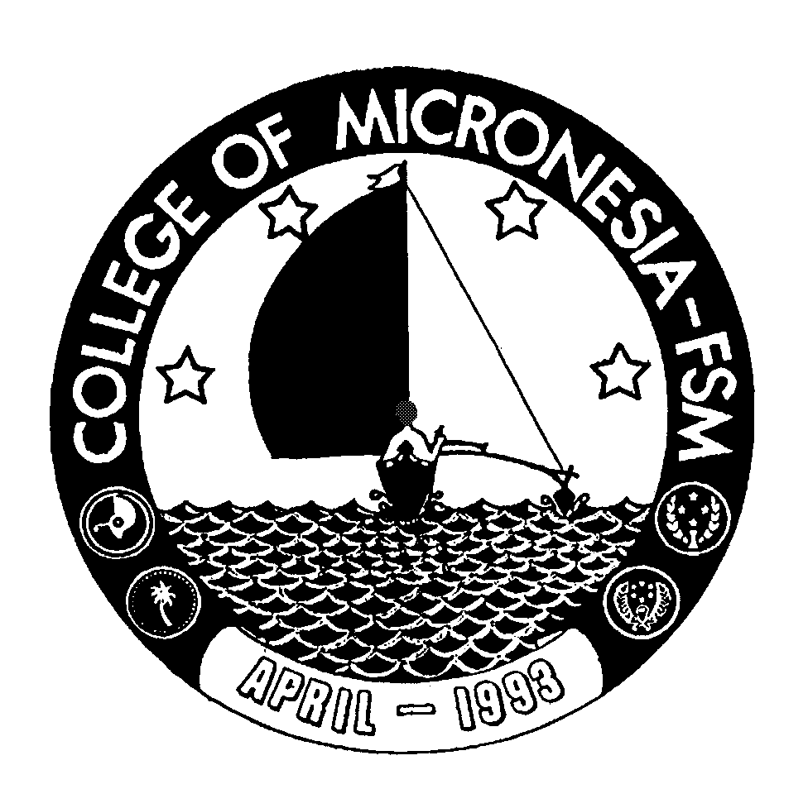
Kolonia, Pohnpei FM 96941

Associate of Science Degree
in
EARLY CHILDHOOD EDUCATION

____________________________________ _________________________________
Name State/Republic

Date of First  Test |  | Placement Test
 | English  Listening/Speaking |  | English  Structure | English  Reading | English  Total | Math

GENERAL EDUCATION CORE REQUIREMENTS |  |  |  |  | MAJOR REQUIREMENTS
English (9 credits) |  |  | Education (37 credits)
EN 110 Advanced Reading | 3_____ |  | ECE 100 Intro to Early Childhood Ed. |  |  |  | 3_____
EN 120a Expository Writing I | 3_____ |  | ECE 101 Curriculum for Early Childhood |  |  |  | 3_____
EN 120b Expository Writing II | 3_____ |  | ECE 102 Working w/Children w/Sp Need |  |  |  | 3_____
 |  |  | ECE 110 The Child, Family & Community |  |  |  | 3_____
Mathematics (3 credits) |  |  | ECE 111 Child Abuse and Neglect |  |  |  | 3_____
Any 100 level or above Mathematics course | 3_____ |  | ECE 211 Lang Develop In Young Child |  |  |  | 3_____
 |  |  | ECE 212 Develop Math Skills Young Child |  |  |  | 3_____
Natural Sciences (7 credits)  A science course with lab or AG 110 or 140 and a non lab science or AG 101 | 4_____  3_____ |  | ECE 213 Infant and Toddler Care  ECE 214 Nutrition, Health & Safety  ECE 215 Internship in Early Childhood |  |  |  | 3_____  3_____  4_____
 |  |  | ED/PY 201 Human Growth & Develop  SS/PY 101 General Psychology |  |  |  | 3_____  3_____
Social Sciences (3 credits)  SS 150 History of Micronesia | 3_____
Computer Application (3 credits)
CA 100 Computer Literacy | 3_____ |  | Humanities Elective (3 credits)
 |  |  | AR 101 Introduction to Art or
Exercise Sports Science (1 credit) |  |  | MU 101 Introduction to Music |  |  |  | 3____
ESS course | 1______
Humanities (3 credits)
Any course in Art, Music, History,  Literature, Philosophy, Language  or SS195 may be taken | 3_____ |  | Total Graduation Requirement |  |  | 69 credits

