COLLEGE OF MICRONESIA-FSM
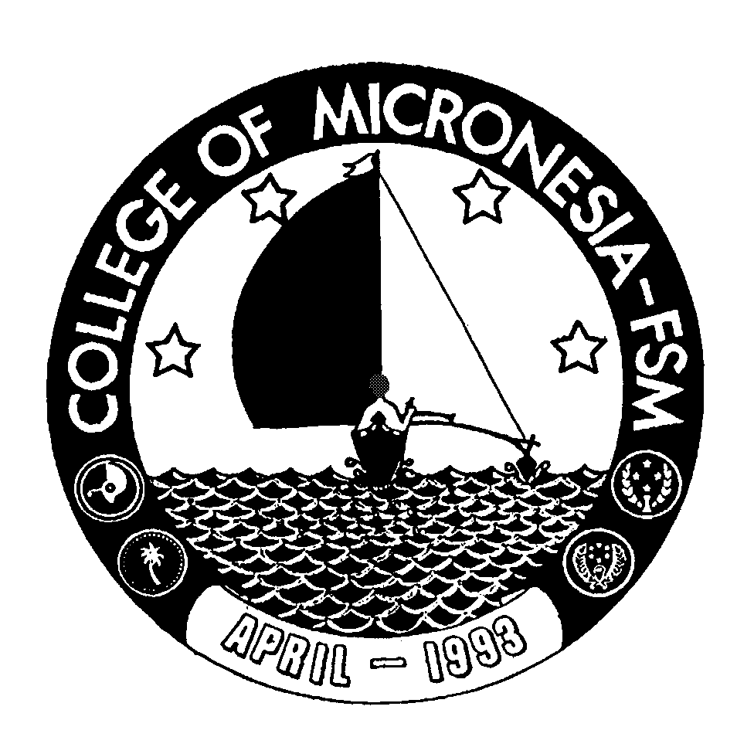
P. O. Box 159
Kolonia, Pohnpei FM 96941

Associate of Arts Degree
in
LIBERAL ARTS/Media Studies

______________________________________ ______________________________
Name State/Republic

Date of First Test |  | Placement Test
 | English  Listening/Speaking |  | English  Structure | English  Reading | English  Total | Math

GENERAL EDUCATION CORE REQUIREMENTS |  |  |  |  |  |  |  |  | MAJOR REQUIREMENTS
 | English (9 credits) |  |  |  |  |  |  | Media Studies (18 credits)
 | EN 110 Advanced Reading | 3______ |  |  |  |  |  | MM 101 Introduction to Journalism |  |  | 3____
 | EN 120a Expository Writing I | 3______ |  |  |  |  |  | MM 110 Intro. to Photo & Video |  |  | 3____
 | EN 120b Expository Writing II | 3______ |  |  |  |  |  | MM 205 Intro. to Media Studies |  |  | 3____
 |  |  |  |  |  |  |  | MM 220 Advanced Video |  |  | 3____
 | Mathematics (3 credits) |  |  |  |  |  |  | MM 225 Multimedia Design |  |  | 3____
 | Any 100 level or above |  |  |  |  |  |  | MM 246 Media Studies Practicum |  |  | 3____
 | Mathematics course | 3_____
 |  |  |  |  |  |  | Communication (3 credits)
 | Natural Sciences (7 credits) |  |  |  |  |  | EN/CO 207 Intro. to Broadcasting |  |  |  |  | 3_____
 | A science course with lab, AG 110 or 140 and | 4_____
 | A non lab science or AG 101 | 3_____
 |  |  |  |  |  |  | Social Sciences (6 credits)
 | Social Sciences (3 credits) |  |  |  |  |  | SS 101 Political Science |  |  |  |  | 3_____
 | SS 150 History of Micronesia | 3_____ |  |  |  |  | SS 120 Introduction to Geography |  |  |  |  | 3_____
 | Computer Application (3 credits) |  |  |  |  |  | Degree Electives (6 credits)
 | CA 100 Computer Literacy | 3_____ |  |  |  |  | Choose two of the following:
 |  |  |  |  |  |  | IS/MM 245 Desktop Publishing |  |  |  |  | 3______
 | Exercise Sports Science (1 credit) |  |  |  |  | MM 120 Film Studies |  |  |  |  |  |  |  | 3______
 | ESS course | 1_____ |  |  |  | MM 240 Computer Animation |  |  |  |  |  |  |  | 3______
 |  |  |  |  |  | SS 125 Geography of the Pacific |  |  |  |  |  |  |  | 3______
 | Humanities (3 credits) |  |  |  |  | SS 195 Micronesian Cultural Studies |  |  |  |  |  |  |  | 3______
 | Any course in Art, Music, |  |  |  |  | SS 205 Micronesian Gov. and Politics |  |  |  |  |  |  |  | 3______
 | History, Philosophy, Language, |  |  |  |  | SS 212 Economy of Micronesia |  |  |  |  |  |  |  | 3______
 | or Culture may be taken | 3_____
 |  |  |  |  |  | Total Graduation Requirements |  |  |  | 62 credits

