COLLEGE OF MICRONESIA-FSM
P. O. Box 159
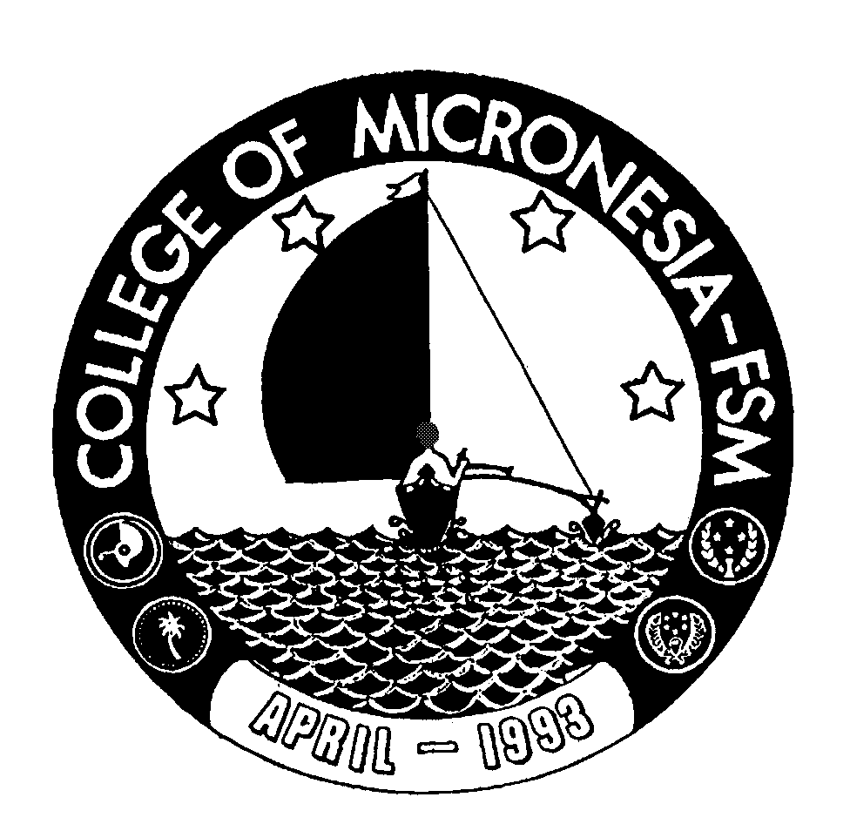
Kolonia, Pohnpei FM 96941

Associate of Arts Degree
in
LIBERAL ARTS-Special Education
__________________________________ ___________________________
Name State/Republic

Date of First Test |  | Placement Test
 | English  Listening/Speaking |  | English  Structure | English  Reading | English  Total | Math

GENERAL EDUCATION CORE REQUIREMENTS |  |  |  |  |  | MAJOR REQUIREMENTS
 |  |  |  |  | Education (19 credits)
English (9 credits) |  |  |  |  | ED 210 Intro. To Prof. Teaching |  |  | 4____
EN 110 Advanced Reading |  | 3____ |  |  | ED 215 Intro. To Except. Child |  |  | 3____
EN 120a Expository Writing I |  | 3____ |  |  | ED 220 Ed. of Except. Children |  |  | 3____
EN 120b Expository Writing II |  | 3____ |  |  | SS/PY 201 Human Growth & Dev. |  |  | 3____
 | Mathematics (3 credits) |  |  |  | MS/ED 210a Math for Teachers |  |  | 3____
 | Any 100 level or above |  |  |  | ED 292a Practicum: Ob. & Part. 3____
 | Mathematics course  (recommended: MS 100 or MS 101 or  MS 150)  Natural Sciences (7credits)  A science course with lab or AG 110 or 140 |  | 3____  4____ |  | Social Sciences (9 credits)  SS 120 Intro. To Geography  SS 170 World Hist. or  SS 171 World Hist. II or  SS 125 Pacific Geography  SS/PY 101 Gen. Psychology |  |  |  | 3____  3____  3____
 | and SC 101 Health Sc. Or  SC 112 Human Nutrition |  | 3____  3____ |  | Natural Sciences (4 credits)  Science with a lab |  |  | 4____
 |  |  |  |  | English (9 credits)
 | Social Sciences (3 credits) |  |  |  | EN/CO 205 Speech Communications |  |  |  | 3____
 | SS 150 History of Micronesia |  | 3____ |  | EN 208 Philosophy |  |  |  | 3____
 |  |  |  |  | One of the following: EN201, 202,
 | Computer Application (3 credits)  CA 100 Computer Literay |  | 3____ |  | 203, 204,205, 206, 207 or EN/ED 233a |  |  |  | 3____
 | Exercise Sports Science (1 credit)
 | ESS course |  | 1____
 | Humanities (3 credits)
 | Any course in art, music, history, literature, philosophy, language or  Culture may be taken |  | 3____
 |  |  |  |  | Total Graduation Requirements |  | 70 Credits

