COLLEGE OF MICRONESIA-FSM
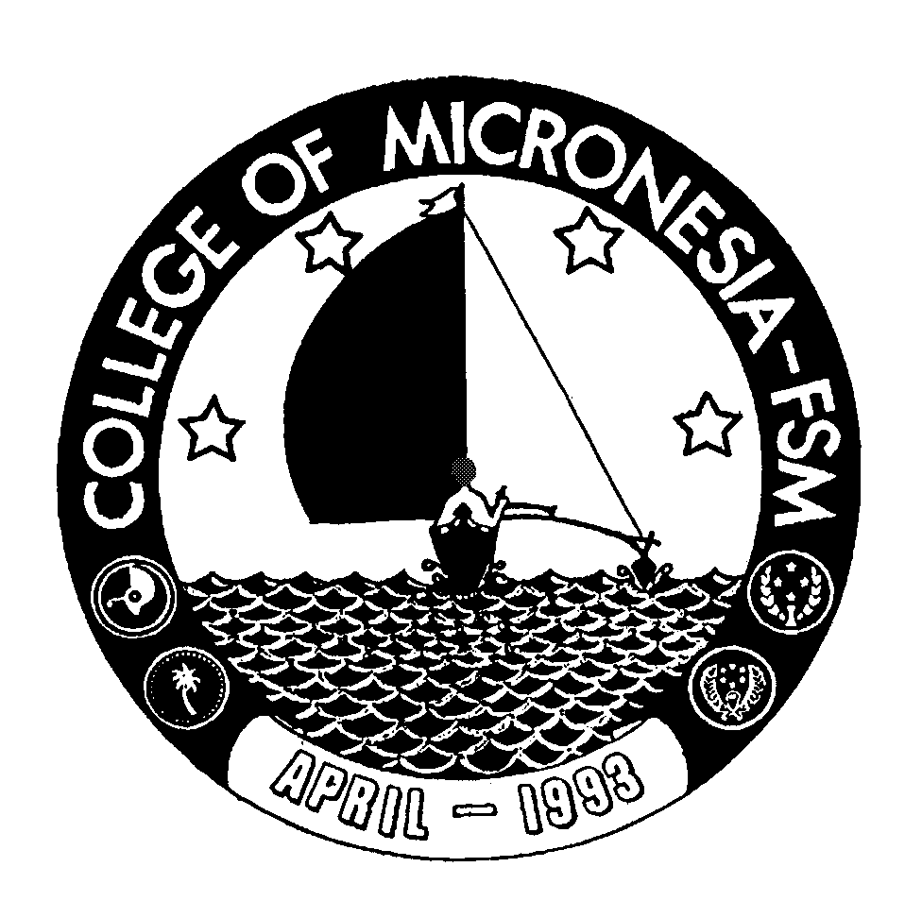
P. O. Box 159
Kolonia, Pohnpei FM 96941

Associate of Arts
in
LIBERAL ARTS/Health Career Opportunity Program

_____________________________________ ____________________________
Name State/Republic

Date of First Test |  | Placement Test
 | English  Listening/Speaking |  | English  Structure | English  Reading | English  Total | Math

GENERAL EDUCATION CORE REQUIREMENTS |  |  |  |  |  |  |  |  | MAJOR REQUIREMENTS
English (9 credits) |  |  |  |  |  |  |  | Natural Science (22 credits)
EN 110 Advanced Reading |  | 3____ |  |  |  |  |  | SC 101 Health Science |  |  |  |  | 3____
EN 120a Expository Writing I |  | 3____ |  |  |  |  |  | SC 112 Intro to Human Nutrition |  |  |  |  | 3____
EN 120b Expository Writing II |  | 3____ |  |  |  |  |  | SC 122a Anatomy & Physiology I |  |  |  |  | 4____
 |  |  |  |  |  |  |  | SC 122b Anatomy & Physiology II |  |  |  |  | 4____
 |  |  |  |  |  |  |  | SC 180 Microbiology |  |  |  |  | 4____
 |  |  |  |  |  |  |  | SC 230 Introduction to Chemistry |  |  |  |  | 4____
Mathematics (3 credits)
Any 100 level or above |  |  |  |  |  |  |  | Psychology (6 credits)
Mathematics course |  | 3____ |  |  |  |  |  | SS/PY 101 General Psychology  ED/PY201 Human Growth & Development |  |  |  |  |  | 3____  3____
 | Natural Sciences (7 credits) |  |  |  |  |  | Speech Communication (3 credits)
 | A science course with lab or AG 110 or 140 and |  | 4____ |  |  |  | EN/CO 205 Speech Communication |  |  |  |  |  | 3____
 | A non lab science or AG 101 |  | 3____ |  |  |  | Mathematics Elective (3 credits)  Any 100 level or above mathematics |  |  |  |  |  | 3____
 | Social Sciences (3 credits)
 | SS 150 History of Micronesia |  | 3____
 | Computer Application (3 credits)
 | CA 100 Computer Literacy |  | 3____
 | Exercise Sports Science (1 credit)
 | ESS course |  | 1____
 |  |  |  |  |  |  | Open Elective (3 credits)
 | Humanities (3 credits) |  |  |  |  |  | ______________________ |  |  |  | 3_____
 | Any course in Art, Music, History,
Philosophy, Language, or Culture  may be taken |  |  | 3____ |  |  |  | Total Graduation Requirement |  |  |  |  | 66 credits

